Task 2

Project: Employee Payroll Management System (PostgreSQL)

---Retrieve employees sorted by salary in descending order---

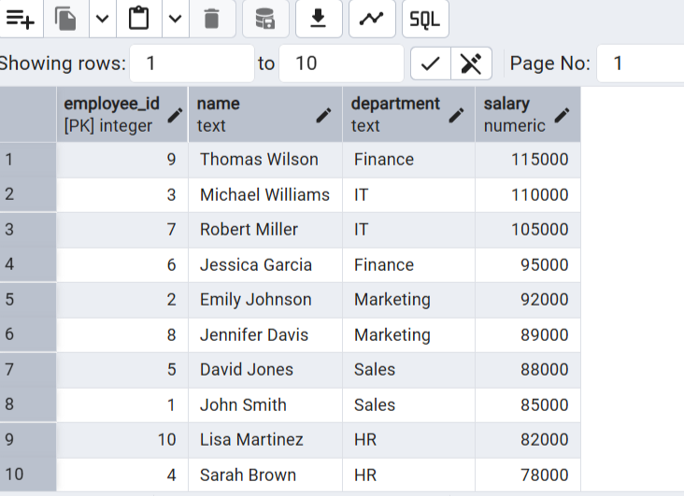

---Find employees with a total compensation (SALARY + BONUS) greater than $100,000---

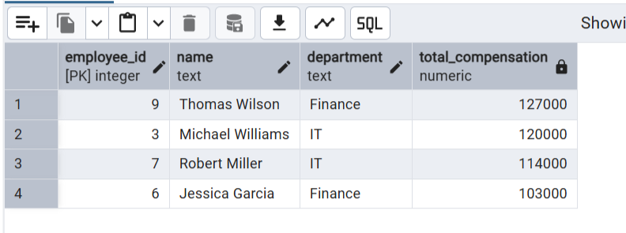

---Update the bonus for employees in the ‘Sales’ department by 10%---

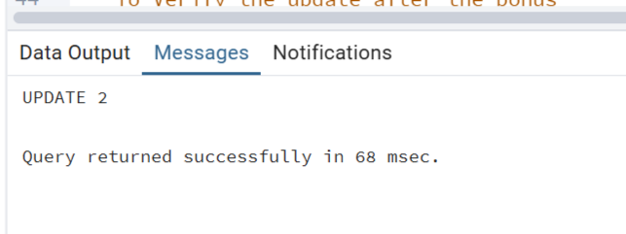

-- To Verify the update after the bonus---

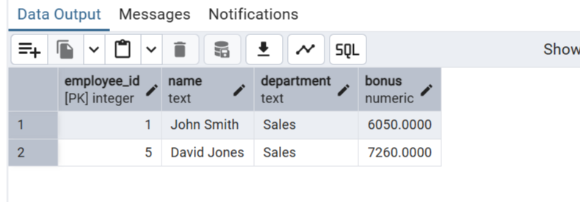

---Calculate the net salary after deducting tax for all employees---

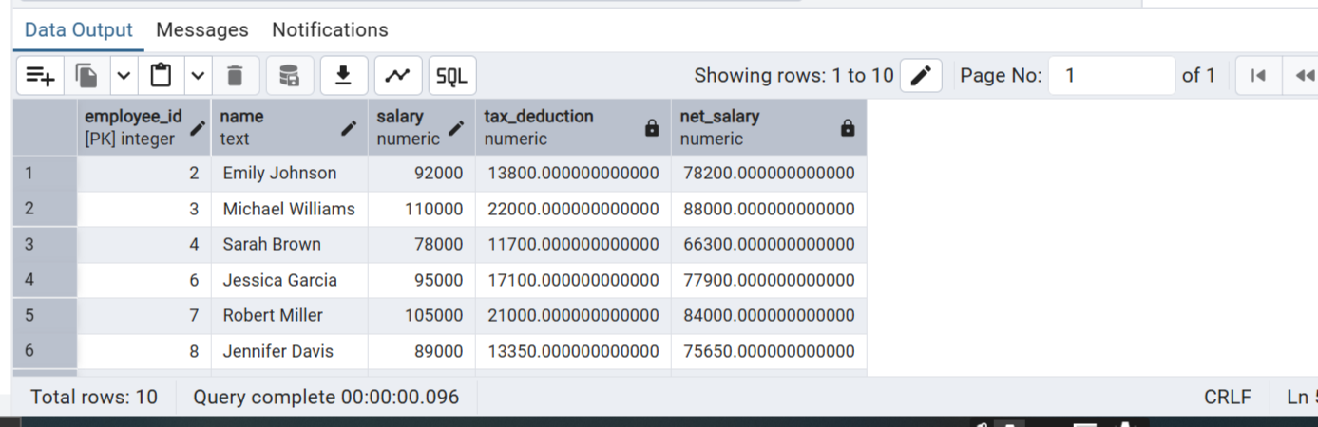

---Retrieve the average, minimum, and maximum salary per department---

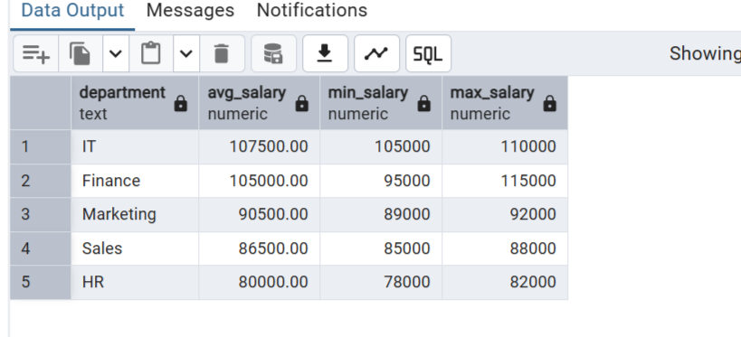

---Advanced queries---

---Employees who joined in the last 6 months (assuming current date is 2023-07-01)---

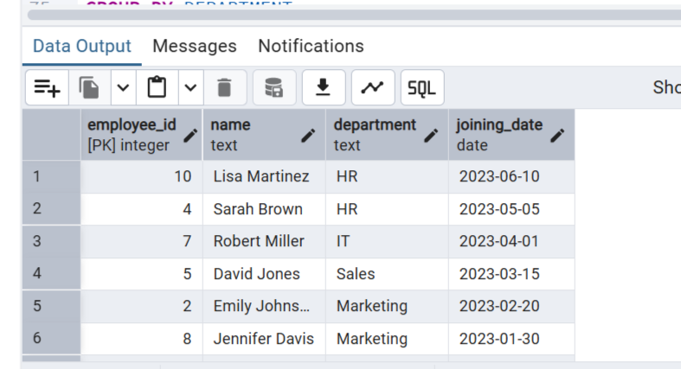

---Group employees by department and count how many employees each has---

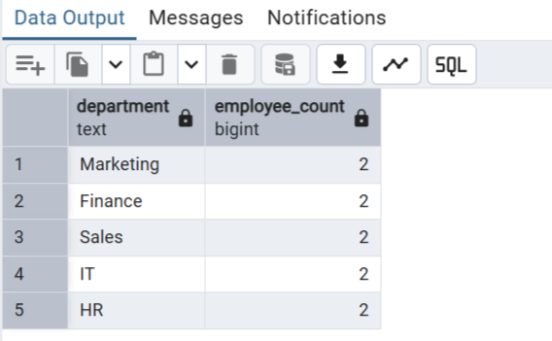

---Find the department with the highest average salary---

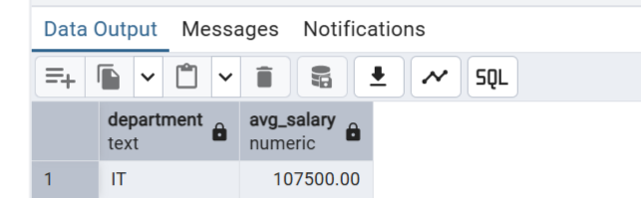

---Identify employees who have the same salary as at least one other employee---

